Name | Ben Chong Wei Heng
Student ID | 34860398
Studio Session | Studio 04 Friday 10.00 AM – 12.00 PM

Part A: URL of the Visualisation

Paste your visualisation URL in the empty space below.
Tip: Test your URL in incognito mode to ensure it is a working URL

https://benc004.github.io/3179/Project%202/

Part B: Domain Description

Describe your domain chosen for DV II
My domain for DV2 is School Enrolment Trends in Malaysia. This domain focuses on government primary and secondary education from 2017 – 2025. The visualization explores enrolment differences across states and school stages. This domain also explores how the trend change with student gender composition and demographic changes.

Describe the Why and Who aspects of your DV II
The purpose of this data visualization is to help audiences understand school enrolment trends in Malaysia. It explains how a relatively stable national total hides differences across state and school stages. It allows audience to understand where enrolment increases and decreases. They can also compare these changes in births and the child population. Furthermore, it also shows school distribution and teacher provision.

The visualization is designed for average Malaysian, especially parents, educators, students, and people who are interested in education.

Describe the “What” aspect of your DV II
This visualization uses two real-world data sources. The first source is the Ministry of Education (MOE), accessed through data.gov.my. It provides data on student enrolment, school counts and teacher counts. These datasets contain national, state and district-level records. This visualization focuses on government primary and secondary education from 2017 to 2025. This dataset is relevant as it provides information that helps identify enrolment differences.
(Student Enrolment, https://data.gov.my/data-catalogue/enrolment_school_district)
(School Counts, https://data.gov.my/data-catalogue/schools_district)
(Teacher Counts, https://data.gov.my/data-catalogue/teachers_district)

The second source is population data accessed through OpenDOSM. The population state dataset provides age, sex, and ethnicity data. The visualization compares population numbers from 2017 and 2025. It also uses data with annual registered births from 2017 to 2024. These datasets provide information on enrolment and future school demands.
(Population state, https://open.dosm.gov.my/data-catalogue/population_state)
(Annual birth state, https://open.dosm.gov.my/data-catalogue/births_annual_state)

The data are stored as CSV files for Vega and Vega-Lite. Relevant records are selected, grouped, and combined for the chart. A GeoJSON file provides the state boundaries for the maps.

Describe the “How” aspect of your DV II
The visualization is built using Vega and Vega-Lite, with HTML, CSS, and JavaScript. It guides readers from national enrolment to state differences. It then introduces population changes, schools, and teacher provision. Each chart answers a specific question within this story.

- Multi-line chart
A multi-line chart was used to compare primary and secondary enrolment from 2017 to 2025. These lines help audiences follow changed over time and compare both school stages.
Marks: Line and Point
Channels:
- Position shows years and student numbers.
- Colour hue represents primary and secondary stages.

- Waterfall chart
A waterfall chart was used to show each state’s contribution to the national enrolment change. It helps audiences understand how increases and decreases balance out each other.
Marks: Line representing bars and the reference line
Channels:
- Length shows each state’s enrolment change.
- Position shows cumulative totals.
- Colour hue represents increases and decreases.
- Horizontal spatial region separates the states.

- Choropleth map
A choropleth map was used to compare enrolment percentage changes across states. The colours help audiences identify geographic patterns of growth and decline. Colour scale is capped at +- 20%.
Marks: Area
Channels:
- Spatial region identifies each state.
- Colour hue represents increases and decreases.
- Colour luminance shows the magnitude within each colour distribution.

- Proportional symbol map
A proportional symbol map was used to show student concentration across states. It appears beside the choropleth to compare student numbers with percentage growth. Larger circles indicate more students.
Marks: Point
Channels:
- Area represents student numbers through circle size.

- Heatmap
A heatmap was used to show annual enrolment changes across states. It helps audiences identify patterns, unusual changes, and differences between each year. Colour scale is capped at +- 5%.
Marks: Area
Channels:
- Colour hue represents increases and decreases.
- Colour luminance shows the magnitude within the displayed range.

- Waffle chart
A waffle chart was used to compare boys’ and girls’ enrolment distribution. The grid makes proportions easier for audience to understand and compare across school stages. Each full square represents one percentage point.
Marks: Area
Channels:
- Area represents each group’s distributions.
- Colour hue represents boys and girls.

- Parallel coordinates plot
A parallel coordinates plot was used to compare child population changes with primary and secondary enrolment changes. Connected lines help audiences follow each state across three measures.
Marks: Line and Point
Channels:
- Spatial region separates the three measure axes.
- Vertical position shows percentage changes.

- Paired population pyramid
A paired population pyramid was used to compare the young population in 2017 and 2025. It helps audiences identify which age groups became larger or smaller.
Marks: Line
Channels:
- Length represents population count.
- Vertical position orders age groups
- Colour hue represents males and females.

- Horizon graph
A horizon graph was used to compare birth trends across locations. Each location uses its own 2017 birth count as its starting point.
Marks: Area
Channels:
- Colour hue represents increases and decreases.
- Colour luminance shows the magnitude within the displayed range.
- Height (length) to show the remaining change within the displayed range.

- Non-contiguous cartogram
A non-contiguous cartogram was used to compare school distribution. It helps audiences distinguish school numbers from average school sizes. Size and colour represent different measures.
Marks: Area represents resized state outlines
Channels:
- Area represents school count.
- Colour luminance represents students per school.

- Scatterplot
A scatterplot was used to compare teacher growth with enrolment growth. The diagonal reference line helps audiences identify which measure grew faster. Purple dots represent primary education while orange square represent secondary education.
Marks: Point
Channels:
- Horizontal position shows enrolment growth.
- Vertical position shows teacher growth.
- Colour hue represents primary and secondary stages.
- Shape represents primary and secondary stages.

- Boxplot
A boxplot was used to compare district students-per-teacher ratios within each state. They reveal differences hidden within state averages.
Marks: Area for boxes, Line for medians and whiskers and point for districts
Channels:
- Horizontal position represents staffing ratios.
- Length shows the middle-half spread through box width.
- Colour hue represents primary and secondary stages.

Part C: Sketch
A URL to a PDF document with an image of your sketch on your GitHub account.
Tip: Test your URL in incognito mode to ensure it is a working URL

https://benc004.github.io/3179/Project%202/DV2_Sketch.pdf
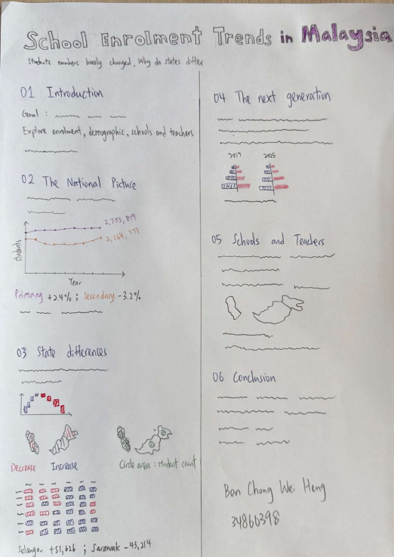

Paste a screenshot of your sketch for your DV II.
Note: Use the entire page here for the screenshot and ensure that it is clearly legible and visible

Part D: Full-size screenshot of your DV II
Paste a full-size screenshot of your DV II assignment from the URL here

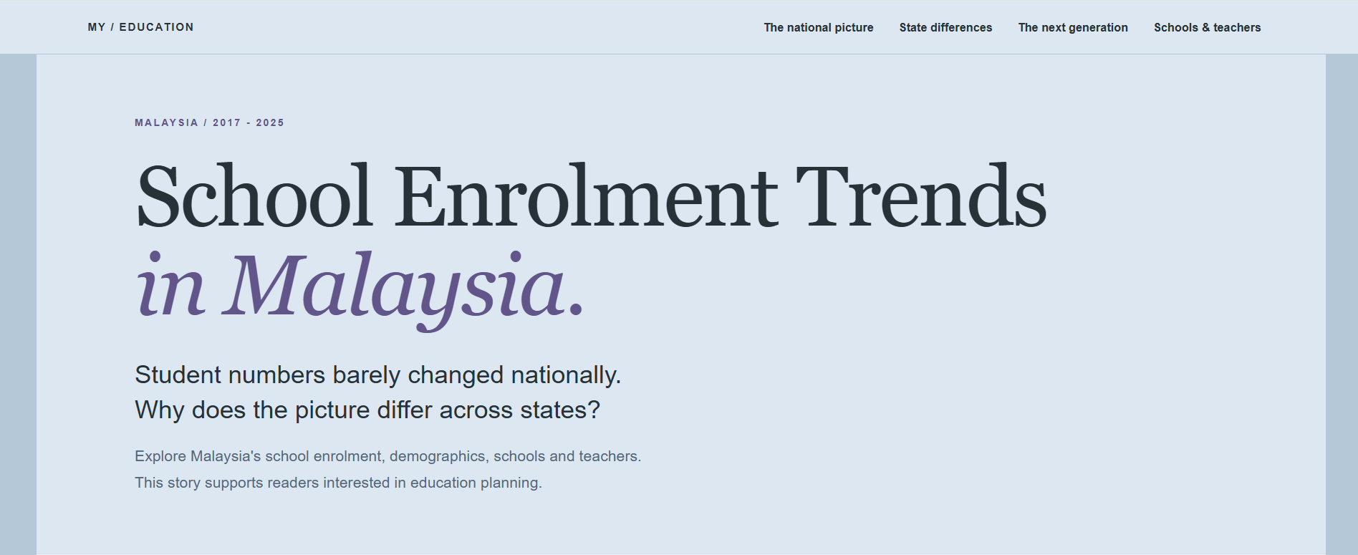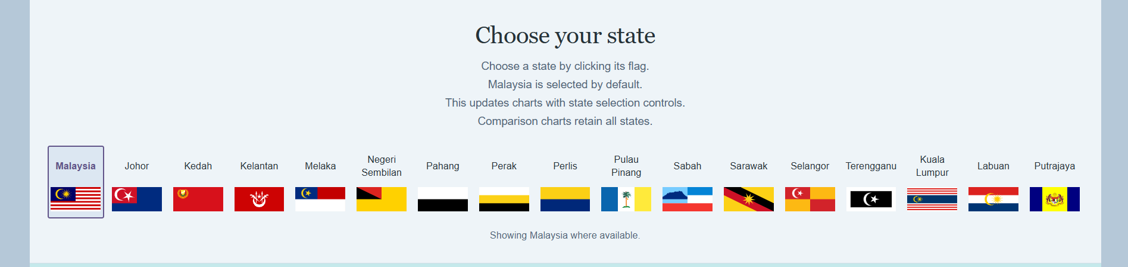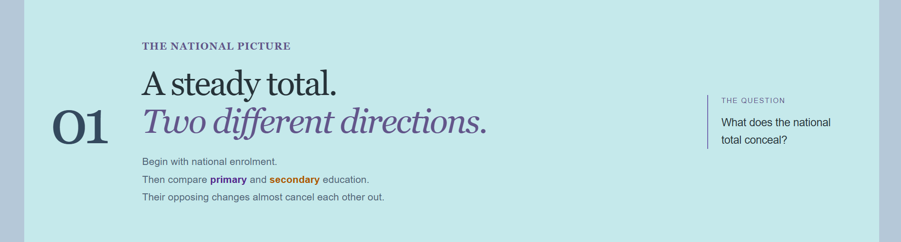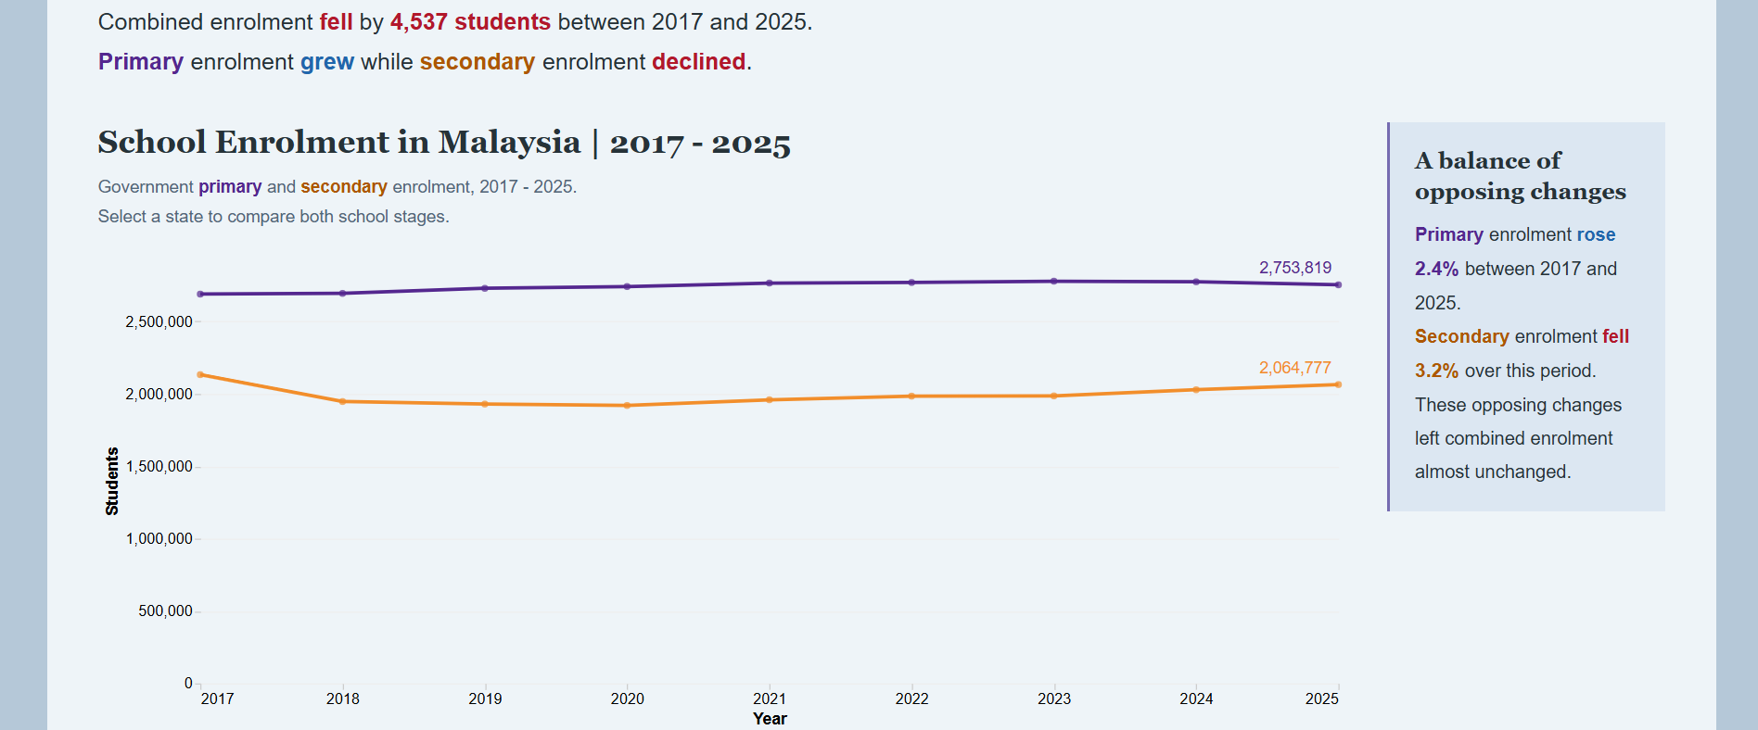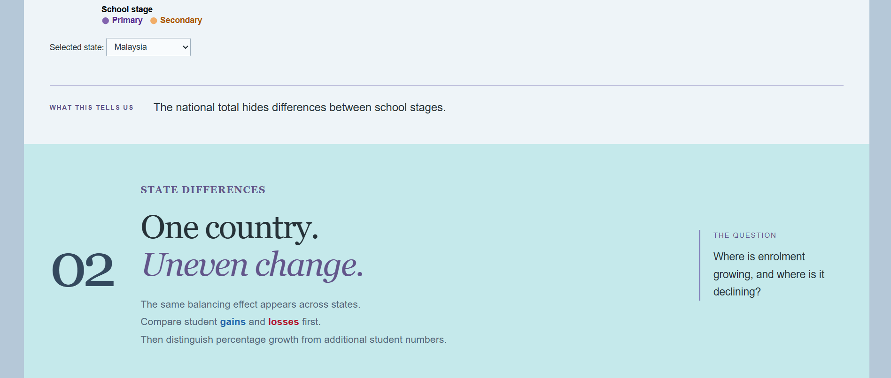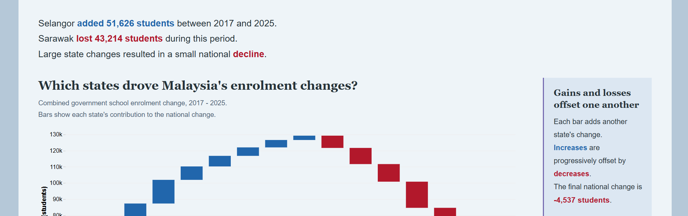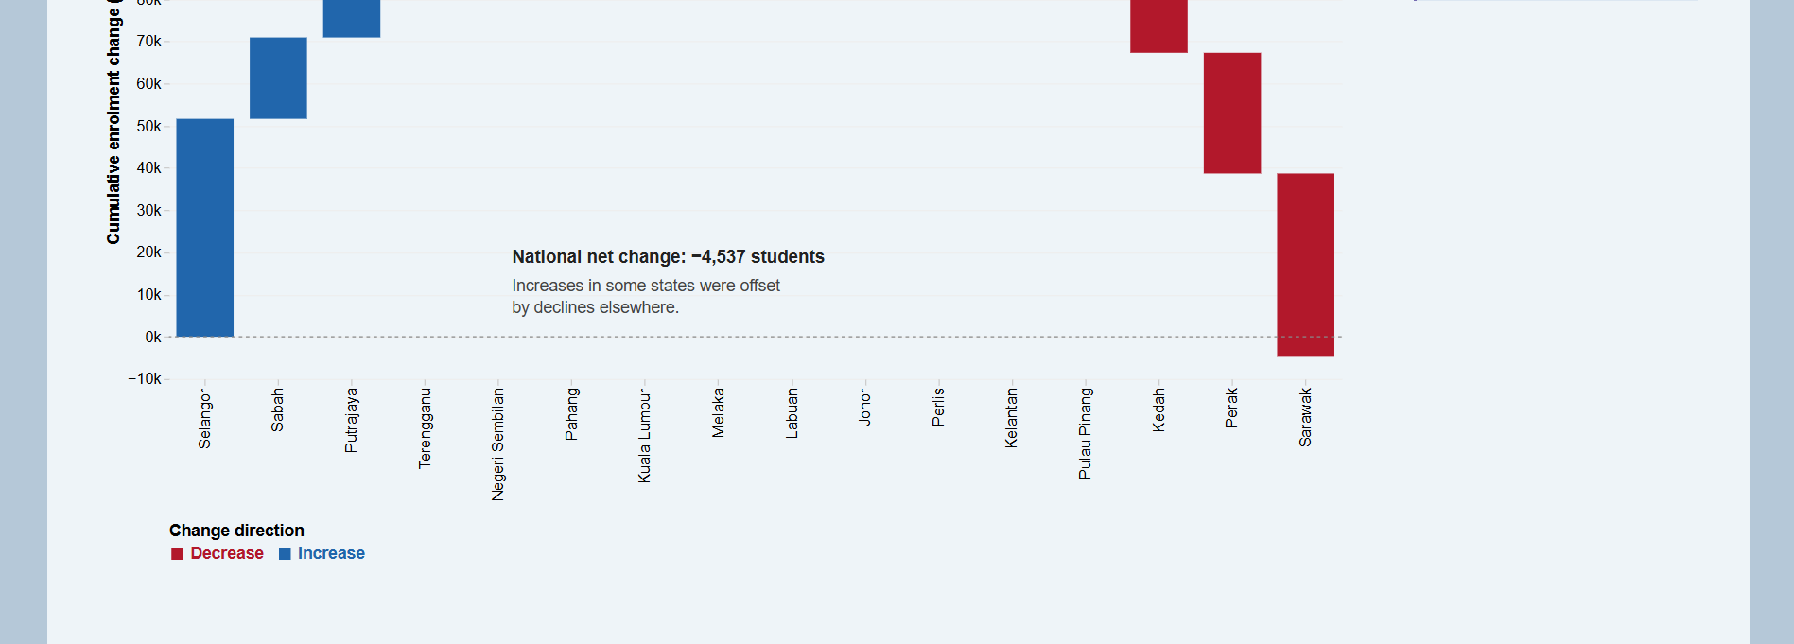
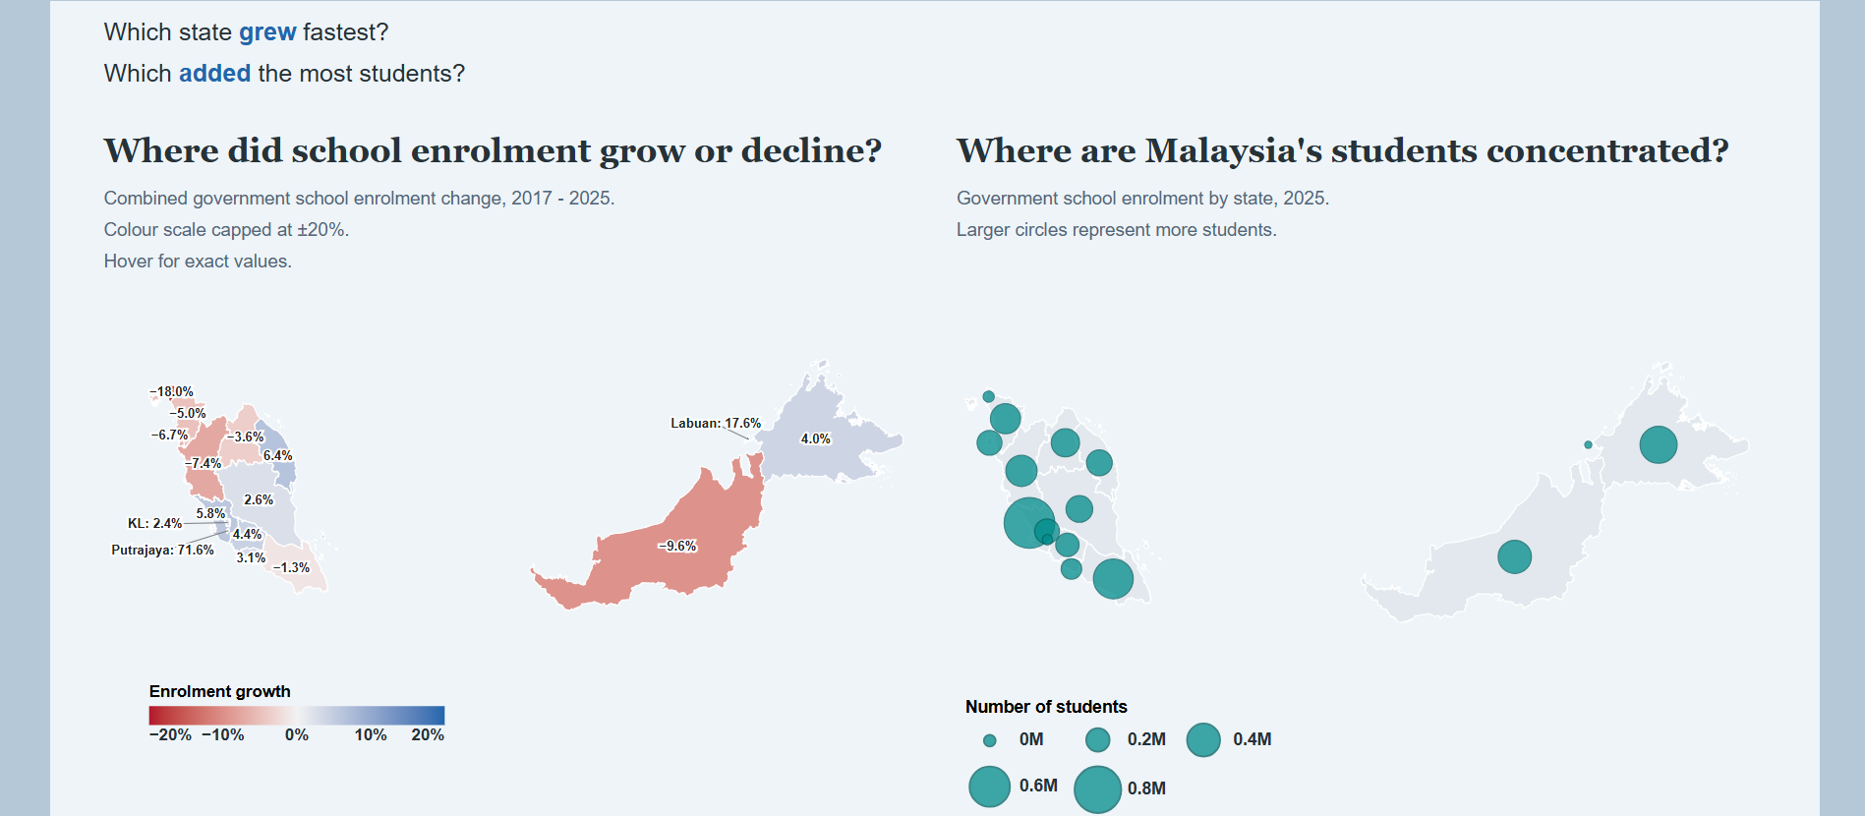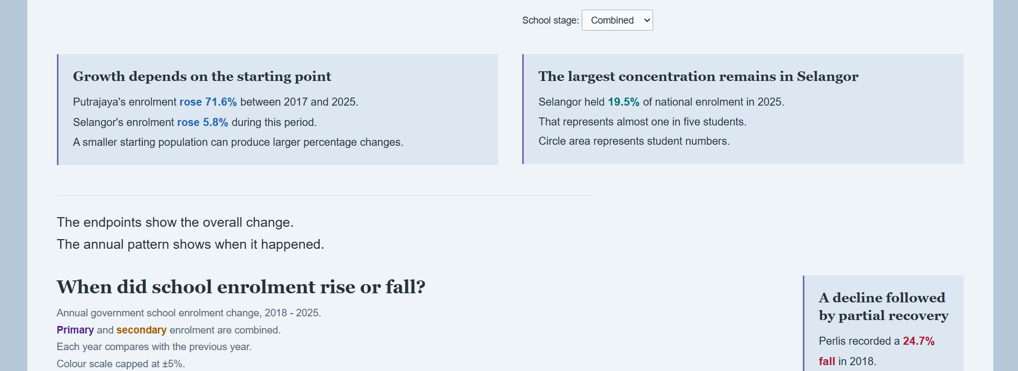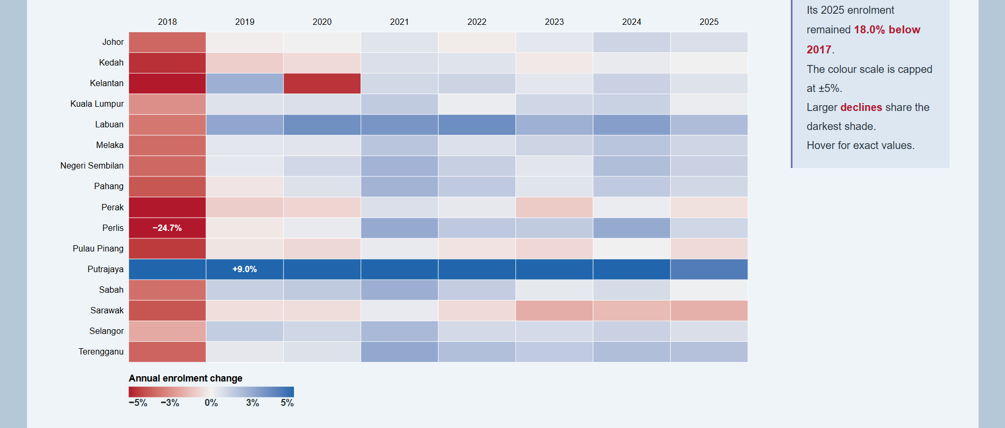
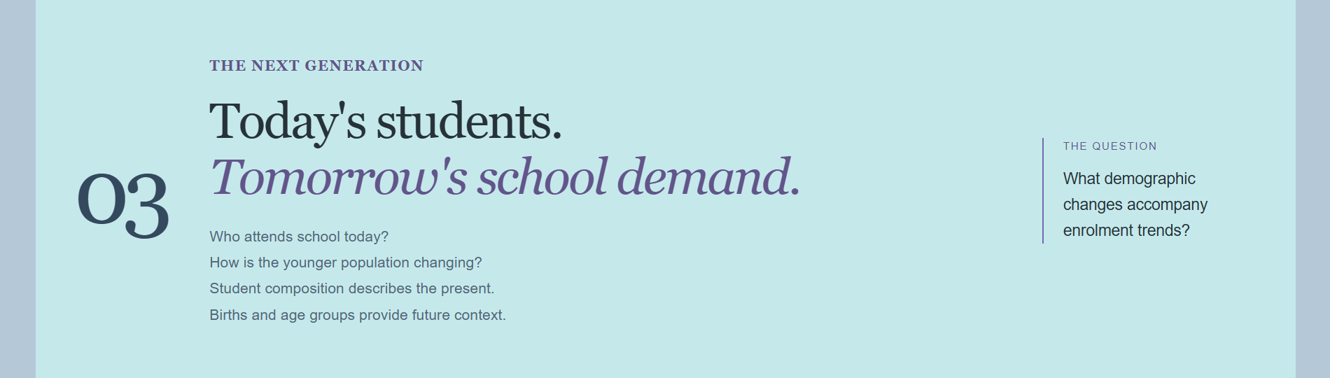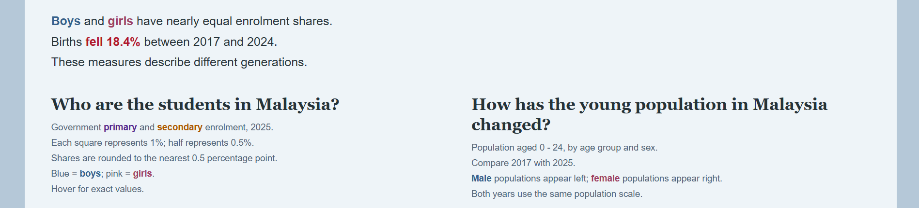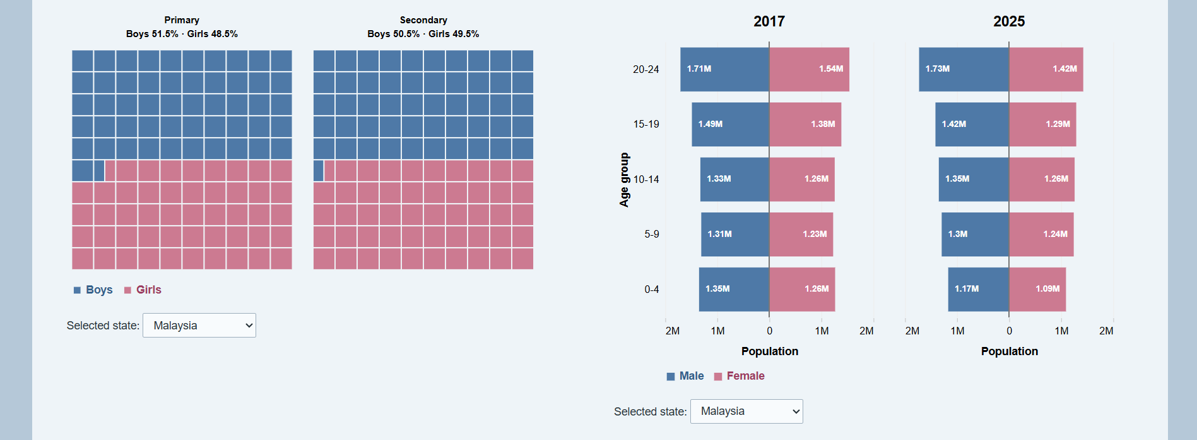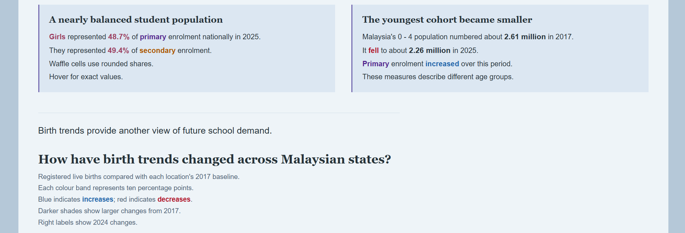
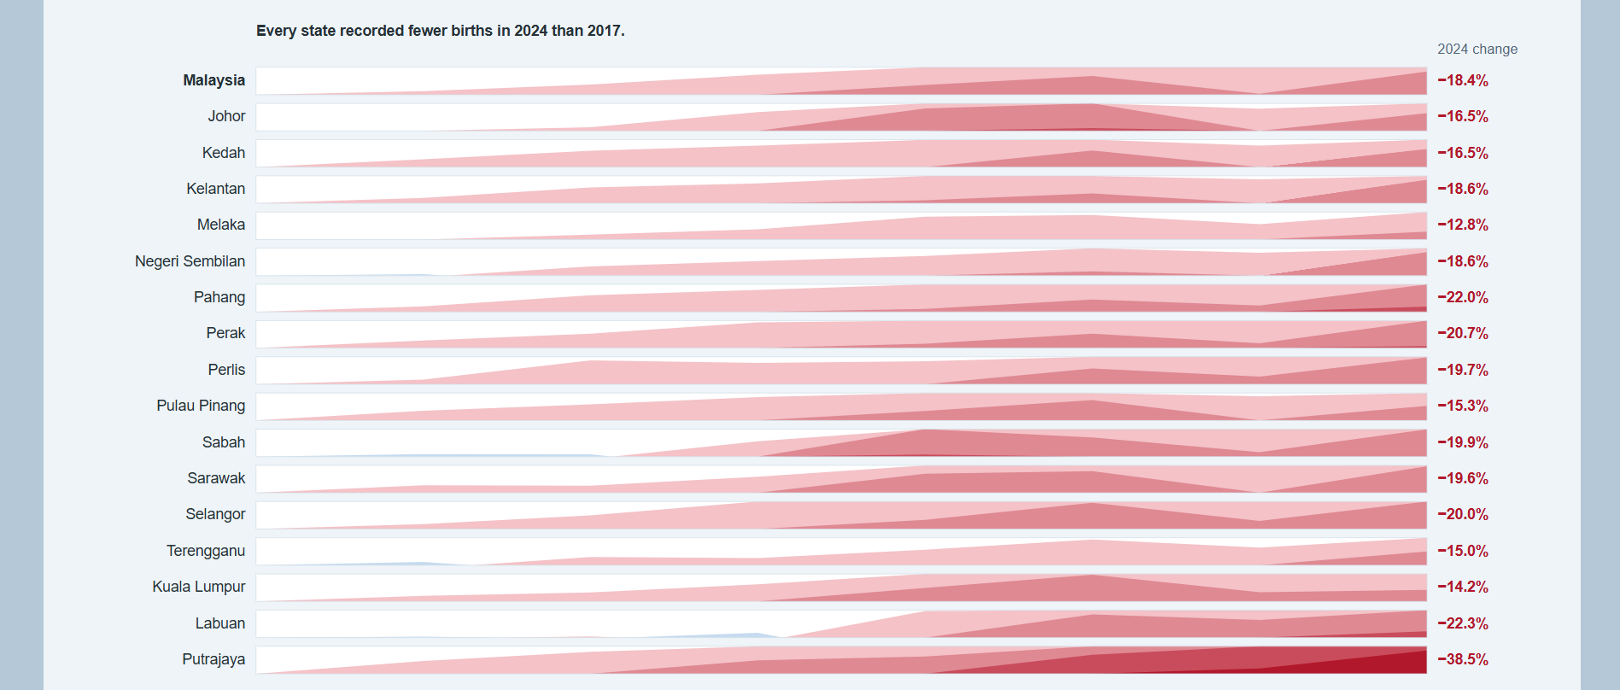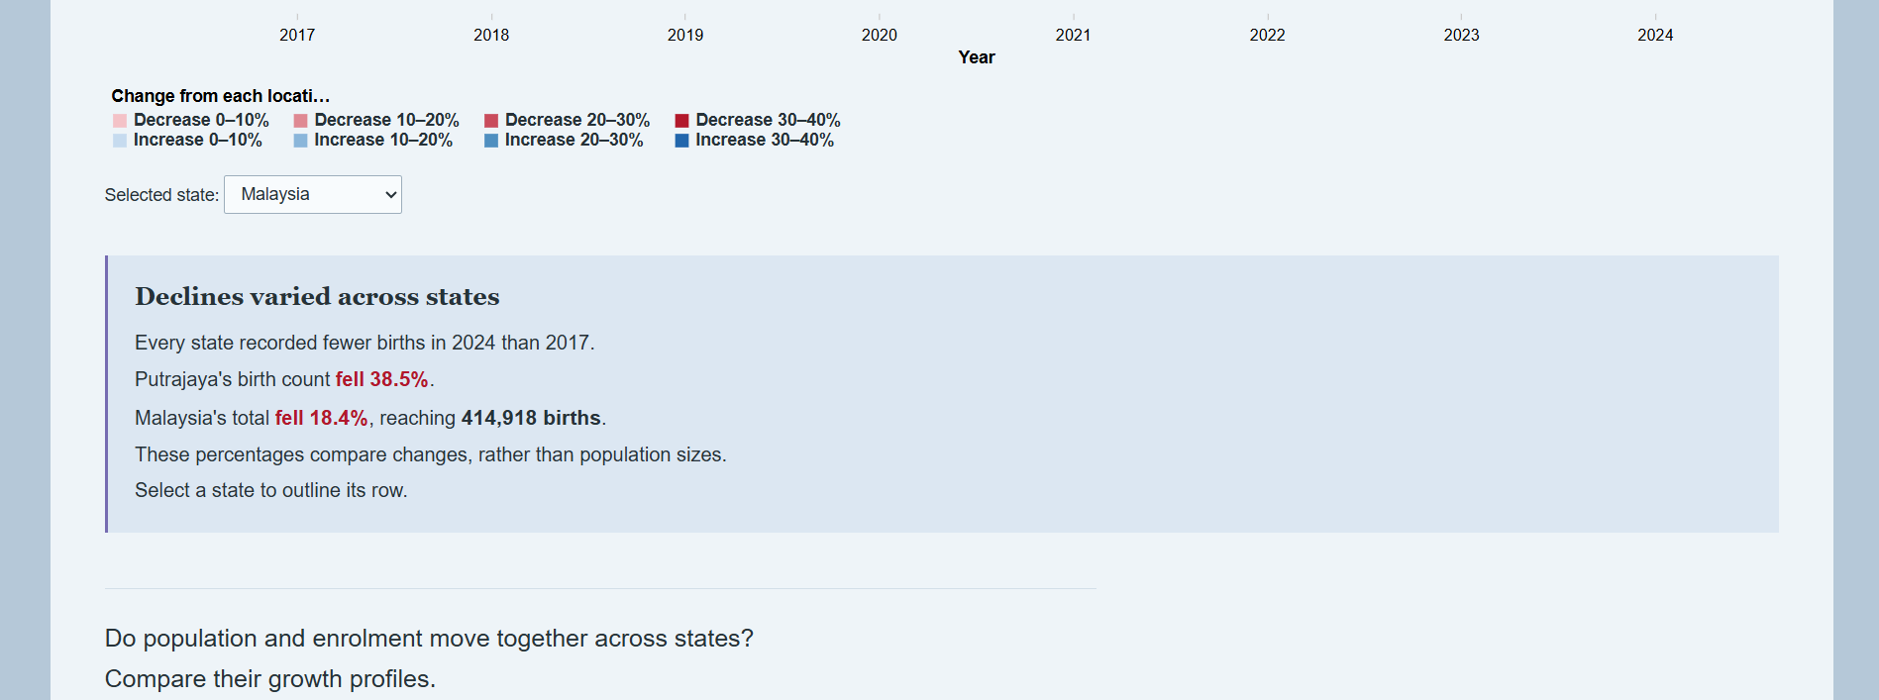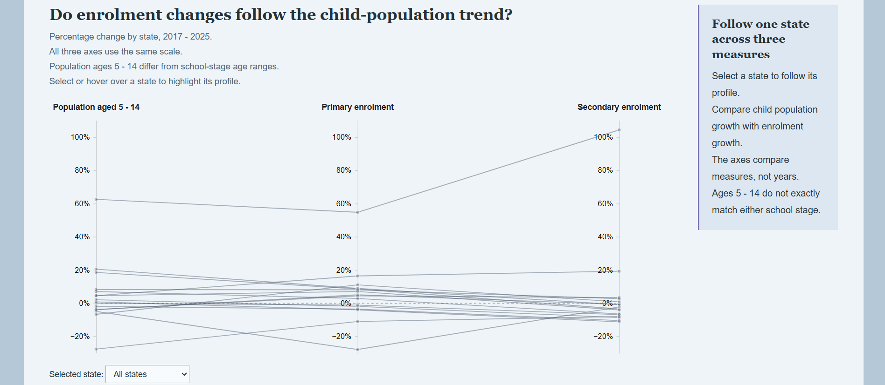
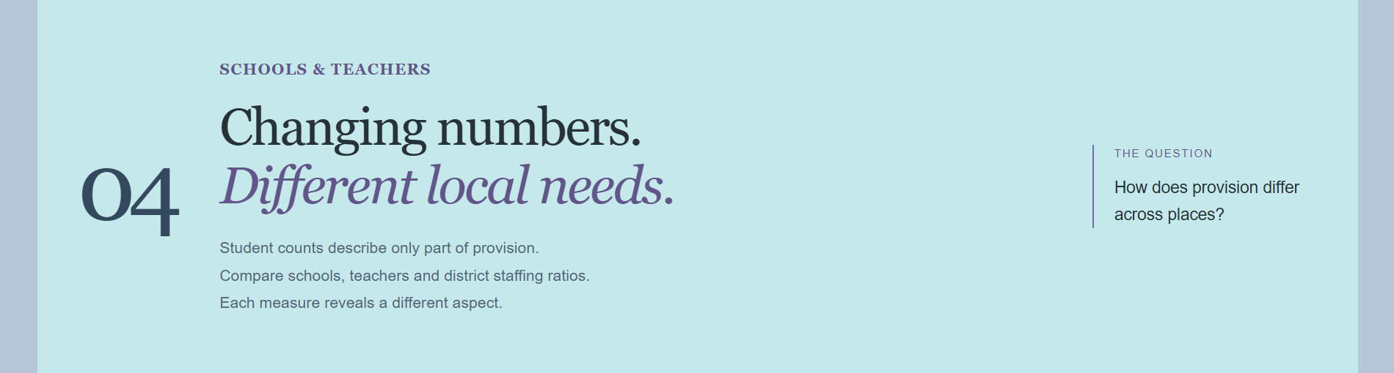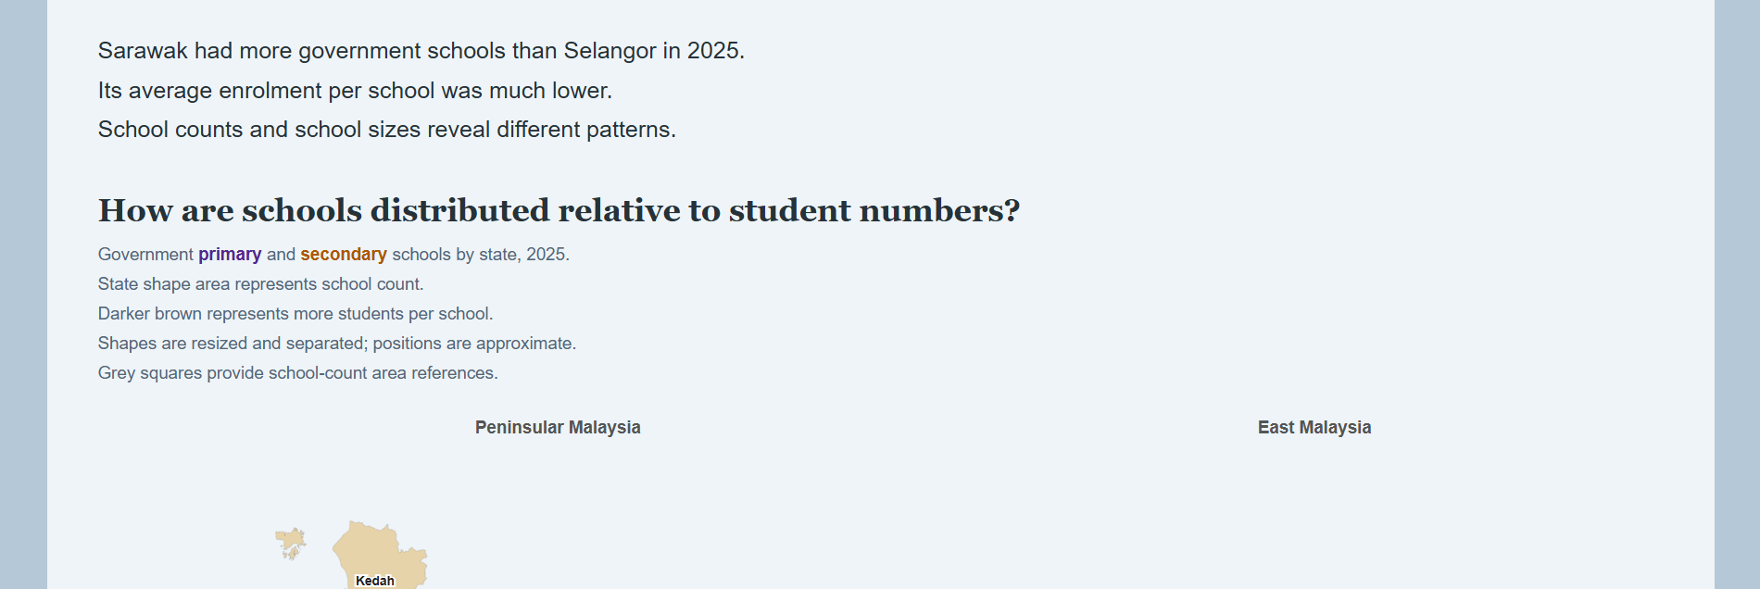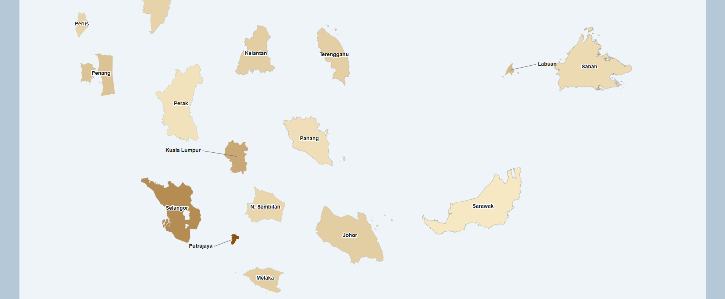
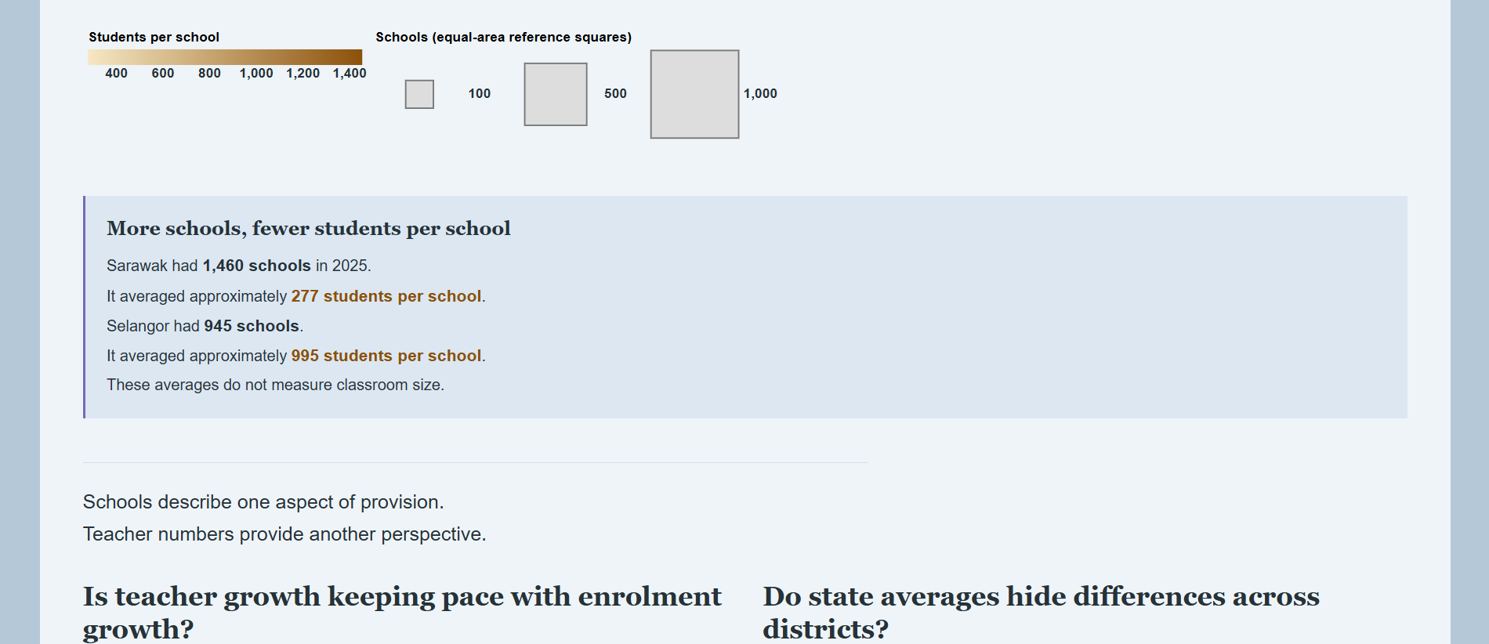
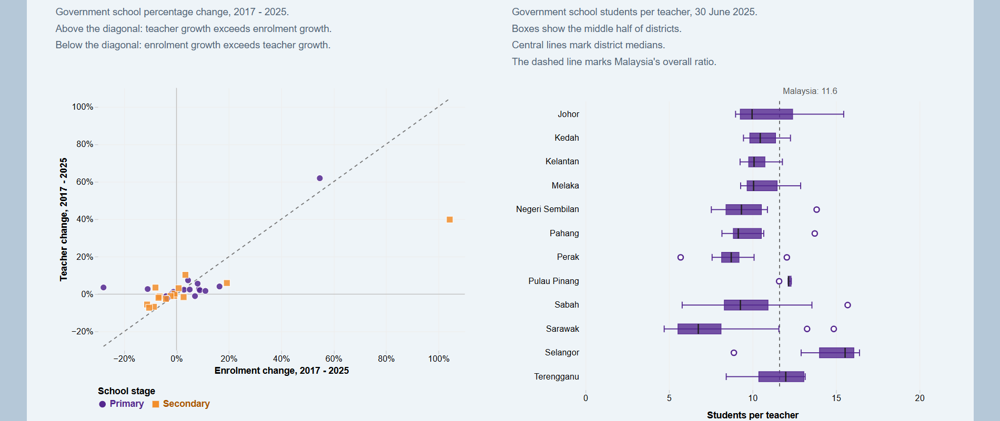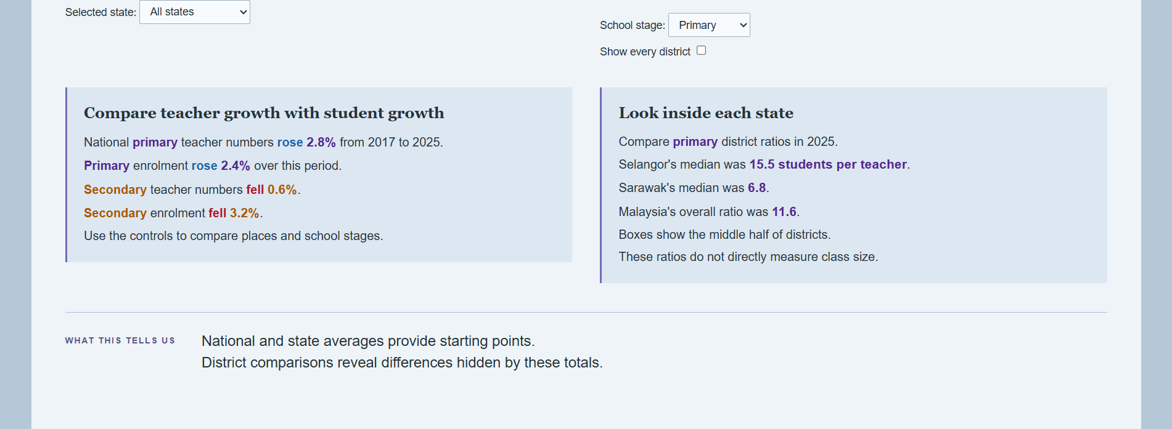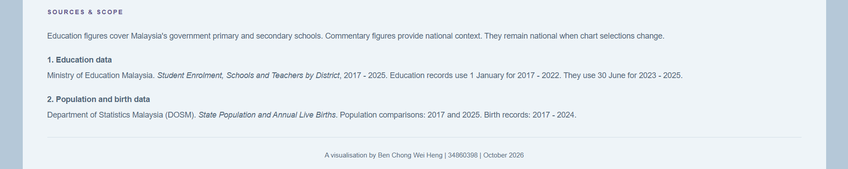

Part E: Generative AI Statement
I acknowledged the use of ChatGPT(https://chatgpt.com/) to give suggestions on my project 2 in modified form. I entered the following prompts on 10th of October:
- Gives ideas on what type of chart is best for visualizing.
- Explain if my charts are good enough to satisfy the question.
- Give ideas on how to modify my sentence so that it sounded more professional.
- Check on my webpage whether the title, text, charts, annotations are in the correct layout.

